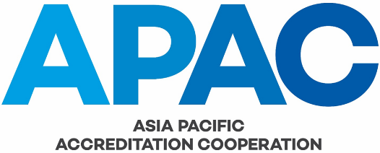

APAC PEER EVALUATION FEEDBACK FORM
FROM: (insert name of organisation here)
We wish to maintain a high level of service to our members and would like to receive your feedback on your recent peer evaluation. Please indicate how the peer evaluation team met your expectations, using the rating and importance criteria listed below, and return this form either by fax or email to the APAC Secretariat. Thank you.
If you would prefer that your comments are NOT discussed with the APAC staff member / peer evaluator concerned, please advise:
YES - Please discuss | NO - Please do not discuss

Rating Criteria Is this factor important to your organisation?
1 - Very Poor 1 - Not important
2 - Poor 2 - Low importance
3 - Average 3 - Important
4 - Good 4 - Very important
5 - Excellent 5 - Critical importance

Conduct of Peer evaluation | Rating | Importance | Your Comments
Assistance offered by Secretariat staff

Timely receipt of pre-peer evaluation correspondence, including peer evaluation plan
Clarity of peer evaluation-related documentation

Conduct of Peer evaluation | Rating | Importance | Your Comments
Technical knowledge / competence of peer evaluator(s) / technical specialist(s) - please specify which
Professionalism of peer evaluator(s) and technical specialist(s) - please specify which
Personal manner / attitude of peer evaluator(s) /technical specialist(s) - please specify which
Interpretation of standard by peer evaluator(s)
Adherence to peer evaluation plan

Depth of peer evaluation

Timely receipt of peer evaluation report
Standard of peer evaluation report

Clarity of peer evaluation report

Fairness of recommendations

Timeliness of whole process

Did the peer evaluation meet your expectations? Please comment:

What changes would you like to suggest to improve the peer evaluation process?

Are there any other comments you would like to offer?

Signature:

Name:

Position:
Date:

Initial / Re-evaluation (please circle)

Programme(s):

