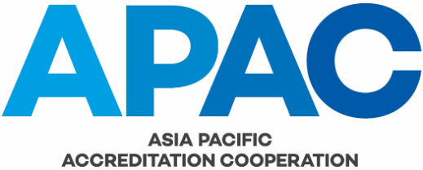

APAC MEMBER SURVEY FORM

ACCREDITED FACILITIES (As at 30 June 20XX)

APAC Member Name:
Economy:
APAC MRA Scope: |  | No. of Accredited Facilities:
ISO 15189 Medical
ISO/IEC 17020 Inspection
ISO/IEC 17025 Calibration
ISO/IEC 17025 Testing
ISO 17034 RMP
ISO/IEC 17043 PTP
Environmental Management Systems EMS
Energy Management Systems EnMS
Food Safety Management Systems FSMS
Information Security Management Systems ISMS
Medical Device Quality Management Systems MDQMS
Occupational Health and Safety Management Systems OHSMS
Quality Management Systems QMS
Persons
GlobalGAP
Product (not including GlobalGAP)
Validation/ Verification

Information prepared by: |  | (Name)
 |  | Date
Please note that we need this information so that we can calculate membership fees for 20XX.

For information on how the fees are calculated please see APAC FFIN-001.

Please return your completed form to the APAC secretariat (secretariat@apac-accreditation.org) by 30 September 20XX. Thank you.

