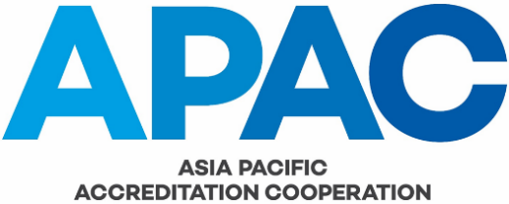

COMMITTEE WORK PLAN TEMPLATE

In accordance with APAC GOV-004, each committee must establish and maintain a work plan that is aligned with APAC’s Strategic Plan. The work plan must identify specific committee activities and include a schedule for the review of the APAC documents for which the committee is responsible. The following template is to be used for reporting to the APAC General Assembly and Executive Committee.

2019-2021 WORK PLAN - APAC <ABC> COMMITTEE
Date proposed | Proposed  by | Brief description of activity | Link to APAC Strategy | APAC funding required  (AUD) | Deliverable(s) | Expected  completion  date | Person responsible | Date approved by APAC | Date and status
2019
2020
2021

