Management System Manual

Issue No. 1.1
Issue Date 8 June 2019
Application Date 8 June 2019

AUTHORSHIP
This document was produced by the APAC Executive Committee.

COPYRIGHT
Copyright in this document belongs to APAC. No part may be reproduced for commercial exploitation without the prior written consent of APAC.

FURTHER INFORMATION
For further information about APAC or this document, please contact the APAC Secretariat. Contact details can be found at www.apac-accreditation.org.

CONTENTS
1. APAC OVERVIEW 4
2. APAC QUALITY POLICY 4
3. APAC STRUCTURE 5
4. EXTERNAL DOCUMENTS APPLICABLE TO APAC AND APAC MRA SIGNATORIES 5
5. OVERVIEW OF APAC DOCUMENTATION 6
6. DOCUMENT CONTROL 6
7. MANAGEMENT REVIEW AND INTERNAL AUDITS 6
8. COMPLAINTS AND APPEALS 7
9. CONFIDENTIALITY 7
10. CONFLICT OF INTEREST 7
11. APAC WEBSITE 8
12. DEPARTURES FROM DOCUMENTED APAC PROCEDURES 8
13. AMENDMENT TABLE 9
APPENDIX 1 – TABLE OF AUTHORITIES 10

- APAC OVERVIEW
The Asia Pacific Accreditation Cooperation Incorporated (APAC) is a cooperation of accreditors of conformity assessment bodies including but not limited to laboratories, inspection bodies, certification bodies, validation and verification bodies, reference material producers and proficiency testing providers in the Asia Pacific region.
APAC was established on 1 January 2019 on the merger of the Asia Pacific Laboratory Accreditation Cooperation (APLAC) and the Pacific Accreditation Cooperation (PAC). APAC is an incorporated body in New Zealand under the Incorporated Societies Act.
Memoranda of Understanding (MoUs) and other recognition arrangements (including multilateral mutual recognition arrangements) signed by APLAC and PAC have been assigned to APAC with the agreement of the third parties concerned.
The APAC General Assembly is the primary body of APAC. The Executive Committee is responsible to the General Assembly for the effective implementation of APAC’s objectives as described in the Constitution, and for the day-to-day management of APAC. The APAC Secretariat supports the work of the General Assembly and the Executive Committee and reports directly to the Executive Committee.

- APAC QUALITY POLICY
APAC commits to complying with its objectives as described in the Constitution.
APAC seeks to enhance the technical competence of conformity assessment bodies including but not limited to testing and calibration laboratories, medical laboratories, inspection bodies, certification bodies, validation and verification bodies, reference materials producers and proficiency testing providers amongst its member organisations.
APAC seeks to demonstrate technical competence to the wider community through the APAC Mutual Recognition Arrangement (MRA).
APAC commits to operate in accordance with the IAF and ILAC recognition criteria set out in IAF/ILAC-A1 and IAF/ILAC-A2 and to remain a recognised region. APAC thereby commits to ensuring that signatories to the APAC MRA operate in accordance with relevant recognition criteria including ISO/IEC 17011 and relevant IAF/ILAC A-series, IAF, ILAC, and APAC documents.
APAC seeks to support trade facilitation in the region and globally through the establishment of an effective and accepted MRA.
APAC seeks to respond effectively to the needs of its member organisations and its stakeholders, including regulators, in the region.
APAC seeks to cooperate with other regional and international bodies with similar or complementary objectives.
The Executive Committee through the APAC Quality Manager is responsible for the development and implementation of APAC’s management system and associated policies and procedures.

- APAC STRUCTURE
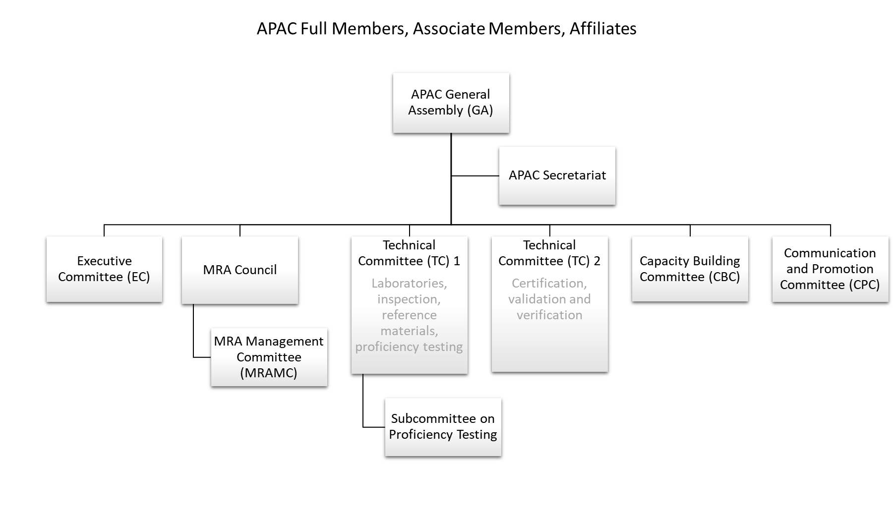
- EXTERNAL DOCUMENTS APPLICABLE TO APAC AND APAC MRA SIGNATORIES
The external documents applicable to APAC’s operation are:
IAF/ILAC-A1 IAF/ILAC Multi-Lateral Mutual Recognition Arrangements (Arrangements): Requirements and Procedures for Evaluation of a Regional Group
IAF/ILAC-A2 IAF/ILAC Multi-Lateral Mutual Recognition Arrangements (Arrangements): Requirements and Procedures for Evaluation of a Single Accreditation Body
The external documents applicable to APAC MRA signatories and applicants to enter APAC MRA are detailed in APAC MRA-002: Procedures for Establishing and Maintaining the APAC Mutual Recognition Arrangement Amongst Accreditation Bodies.

- OVERVIEW OF APAC DOCUMENTATION

Document(s) | Authorship
Governance  (APAC GOV and FGOV documents) | Executive Committee
APAC Management System Manual  (APAC MS and FMS documents) | Quality Manager
MRA Series  (APAC MRA documents) | MRA Council
Finance  (APAC FIN and FFIN documents) | APAC Treasurer
Personnel  (APAC PER and FPER documents) | Executive Committee/Secretariat
Capacity Building Committee series  (APAC CBC documents) | Capacity Building Committee
Communications and Promotion Committee series  (APAC COM documents) | Communications and Promotion Committee
Technical Committee series  (APAC TECx and FTECx documents) | Technical Committees

- DOCUMENT CONTROL
The procedure for publication of new documents and the revision or withdrawal of existing documents is described in APAC MS-001 Document and Records Control. It is the responsibility of the relevant APAC committee, committee Working Group, MRA Council or APAC Secretariat to ensure that this procedure is followed when producing a new APAC document or revising an existing APAC document.

- MANAGEMENT REVIEW AND INTERNAL AUDITS
The APAC Executive Committee with the Quality Manager are responsible for ensuring that a review of APAC’s management system is undertaken at least annually.
An internal audit shall be scheduled by the Quality Manager in conjunction with the APAC Executive Committee at intervals of not more than 24 months unless there is an identified need to do an earlier audit.
The procedures for Management Review and Internal Audits are given in APAC MS-003 Internal Audit and Management Review.

- COMPLAINTS AND APPEALS
The procedure for handling any complaint against APAC or against APAC members and MRA signatories, including in relation to breaches of the APAC Code of Ethics, and against APAC procedures and practices is given in APAC MS-004 Complaints and Appeals Process. This also covers disputes between APAC members and complaints about members forwarded to APAC from IAF or ILAC.
This procedure also covers the handling of appeals against decisions made by APAC, except those made by the APAC MRA Council relating to APAC MRA signatory status (refer to APAC MRA-001). Such decisions will generally have been made by the General Assembly and might include but not be limited to refusal of membership to an applicant organisation, suspension or withdrawal of membership, or imposition of a sanction for a breach of the Code of Ethics.
Any complaint and appeal must be submitted in writing with the relevant supporting documentation.

- CONFIDENTIALITY
Certain information available to APAC Members, APAC committees, APAC MRA Council and APAC evaluation teams is privileged information and shall be treated as confidential.
APAC evaluation teams and attendees at the APAC MRA Council shall sign the confidentiality statement in the form APAC FGOV-007.
For all other instances when confidentiality is required, the confidentiality statement APAC FGOV-007 shall be prepared by the Secretariat and signed by the relevant APAC members, committee members or others present at the meeting or event.

- CONFLICT OF INTEREST
From time to time a General Assembly, Executive Committee, Committee or other meeting may be asked to consider and decide on a matter with which a participant in the meeting may have a conflict of interest.
The person affected shall declare his/her interest and a decision will be taken as to whether it is a conflict and what, if any, action is necessary. In some cases, a declaration of the interest will be sufficient. In other cases, disallowing the person to participate in discussion about an issue or exclusion from the meeting for the particular agenda item may be necessary. The decision is the responsibility of the Chair of the meeting and it shall be recorded in the minutes.
A request that Executive Committee members state any potential conflict of interest with a particular agenda item shall be a standing agenda item for all Executive Committee meetings.

- APAC WEBSITE
APAC’s website is found at www.apac-accreditation.org.
The APAC Secretariat administers the APAC website and is responsible for assigning access permissions. The Executive Committee, on behalf of APAC, signs a Contract for the provision and maintenance of the website with a provider selected by the Executive Committee.
The Executive Committee, on behalf of the APAC General Assembly and via the Secretariat, is the arbiter of the content of the APAC website, both coverage and text. It is also responsible for authorising additions to the website content. Proposals for changes in content, coverage and text may come from any APAC Member and/or committee.

- DEPARTURES FROM DOCUMENTED APAC PROCEDURES
APAC procedures are prepared, approved and continually improved based on experiences gained through its on-going operation and through the input of Members. All procedures are subjected to a formal review at regular intervals. However, they cannot anticipate all eventualities and judgement is needed in the interpretation of the requirements to ensure that the initial intent of a particular requirement is met. From time to time, circumstances will arise where existing procedures are inadequate to address the situation at hand or cannot be fully implemented without jeopardising the smooth operation of APAC activities.
Departures from documented procedures if they are only of a minor administrative nature are permissible under appropriate circumstances but shall be fully justified, documented and authorised. Such departures may be:
- Planned departures, where it is recognised in advance that APAC procedures will not be adequate or are unable to be fulfilled and there is insufficient time to draft and approve new/amended procedures;
- Unplanned departures, where departures have already occurred and/or there is an urgent need to authorise alternative actions to ensure necessary activities can continue.
Appendix 1 sets out the authorities for dealing with both planned and unplanned departures from APAC procedures, and also provides guidance on possible complementary actions.
Note: APAC documents that are not considered “procedural requirements documents” are not included in this appendix and are therefore not covered by this procedure.

- AMENDMENT TABLE
This table provides a summary of the changes to the document with this issue.

Section(s) | Amendment(s)
5 | 2019/06/08 Updated structure diagram
All | New issue on establishment of APAC. Document based upon APLAC MS 000 APLAC Management System Manual Issue No. 1
End

APPENDIX 1 – TABLE OF AUTHORITIES

APAC Procedural Document | Title/Section | Unplanned Departure |  | Planned Departure
 |  | Authority | Associated Action | Authority | Associated Action
GOV-001 | APAC Constitution | General Assembly |  | General Assembly
GOV-002 | APAC Regulations and Codes | General Assembly |  | General Assembly
MS-000 | Management System Description | APAC Secretary | Notify APAC Chair as soon as practical | Executive Committee | Review need for new or amended procedure
FGOV-005 | Membership Application | Executive Committee | Notify General Assembly at the appropriate time | Executive Committee
MTG-001 | Requirements for Hosting Annual Meetings | Meeting Hosts | Inform APAC Secretary as soon as practical | Executive Committee
COM-002 | Use of the APAC Logo | Executive Committee |  | Executive Committee
 | APAC Strategic Plan | Executive Committee |  | General Assembly
CBC-001 | Capacity Building Activities and Funding | Capacity Building Committee Chair |  | Capacity Building Committee
FIN-001 | APAC Financial management | Executive Committee |  | Executive Committee
MRA-001 | Procedures for Establishing and Maintaining Mutual Recognition Amongst APAC Accreditation Bodies | MRA Council Chair | Ensure:  - MRA Council is informed of departures at the appropriate time  - If necessary, evaluation Team Leaders informed as soon as possible (with Team Leaders to inform members of their team) | MRA Council | Ensure, if necessary, evaluation Team Leaders informed as soon as possible (with Team Leaders to inform members of their team)
MRA-001 | Part 1 - General | MRA Council | Ensure, if necessary, evaluation Team Leaders informed as soon as possible (with Team Leaders to inform members of their team) | General Assembly | Ensure, if necessary, evaluation Team Leaders informed as soon as possible (with Team Leaders to inform members of their team)
MRA-001 | Part 2 - The APAC MRA Process | MRA Council Chair | Ensure:  - MRA Council is informed of departures at the appropriate time  - If necessary, evaluation Team Leaders informed as soon as possible (with Team Leaders to inform members of their team) | MRA Council | Ensure, if necessary, evaluation Team Leaders informed as soon as possible (with Team Leaders to inform members of their team)
MRA-001 | - Application for Signatory Status | MRA MC Chair | Inform MRA Council at time of review | MRA Council
MRA-001 | - Team Leader appointment | MRA MC Chair | Seek MRA MC endorsement of the departure as soon as practical | MRA MC
MRA-001 | - Team composition | Evaluation Team Leader | Notify MRA MC Chair as soon as practical | Evaluation Team Leader | Notify MRA Council MC Chair as soon as practical
MRA-001 | Part 3 - The Evaluation Process  - During on-site evaluations | Evaluation Team Leader | Notify MRA MC Chair as soon as practical | MRA MC Chair | Ensure:  - MRA Council is informed of departures at the appropriate time  - If necessary, other evaluation Team Leaders informed as soon as possible (with Team Leaders to inform members of their team)
MRA-001 | - Pre- & post- on-site evaluation procedures | MRA MC Chair | Ensure:  - MRA Council is informed of departures at the appropriate time  - If necessary, evaluation Team Leaders informed as soon as possible (with Team Leaders to inform members of their team) | MRA MC Chair | Ensure:  - MRA Council is informed of departures at the appropriate time  - If necessary, evaluation Team Leaders informed as soon as possible (with Team Leaders to inform members of their team)
MRA-001 | - Evaluation reports & team recommendations | MRA MC Chair | Ensure:  - MRA Council is informed of departures at the appropriate time  - If necessary, evaluation Team Leaders informed as soon as possible (with Team Leaders to inform members of their team) | MRA Council Chair | Ensure:  - MRA Council is informed of departures at the appropriate time  - If necessary, evaluation Team Leaders informed as soon as possible (with Team Leaders to inform members of their team)
MRA-003 | APAC MRA Council – Rules for its Operation | MRA MC Chair |  | MRA Council
MRA-003 | - Decision-making (all aspects) | MRA Council |  | MRA Council
MRA-004 | Selection, Qualification and Monitoring of APAC Peer Evaluators | MRA MC Chair | Inform MRA MC as soon as practical.  Ensure:  - MRA Council is informed of departures at the appropriate time  - If necessary, evaluation Team Leaders informed as soon as possible (with Team Leaders to inform members of their team) | MRA Council | Ensure, if necessary, evaluation Team Leaders informed as soon as possible (with Team Leaders to inform members of their team)
MRA-006 | A Guide for the Planning and Conduct of Evaluations | MRA MC Chair | Ensure:  - MRA Council is informed of departures at the appropriate time  - If necessary, other relevant evaluation Team Leaders informed as soon as possible (with Team Leaders to inform members of their team) | MRA Council | Ensure, if necessary, other relevant evaluation Team Leaders informed as soon as possible (with Team Leaders to inform members of their team)

