Vexatious Behaviour Process

Issue No. 1.0
Issue Date 17 September 2020
Application Date 17 September 2020

AUTHORSHIP
This document was produced by the APAC Executive Committee.

COPYRIGHT
Copyright in this document belongs to APAC. No part may be reproduced for commercial exploitation without the prior written consent of APAC.

FURTHER INFORMATION
For further information about APAC or this document, please contact the APAC Secretariat. Contact details can be found at www.apac-accreditation.org.

CONTENTS
1. SCOPE 4
2. GENERAL 4
3. DEFINITIONS 4
4. IDENTIFYING VEXATIOUS BEHAVIOUR 5
5. MANAGEMENT OF COMMUNICATIONS 7
6. NOTIFICATION OF INTENT TO CEASE COMMUNICATION 7
7. PROCESS 8
8. AMENDMENT TABLE 8

SCOPE
APAC MS-004 details the general process for the investigation and resolution of complaints. This document provides a supplementary process for identification and management of vexatious behaviour, including unreasonably persistent or otherwise unacceptable enquiries or complaints.

GENERAL
2.1. It is the duty of APAC to receive and manage feedback from interested parties relating to enquiries and complaints. All feedback is valued and if appropriate, it is used to identify and implement subsequent improvements.

2.2. Interested parties, including complainants, are dealt with in a fair and equal manner, without any preference or prejudice towards them; however, APAC does not tolerate vexatious behaviour. If it occurs, action(s) will be taken to protect the wellbeing of APAC’s personnel, Members and Affiliates, the integrity of APAC’s processes and reputation.

2.3. This process is intended to assist in making decisions regarding vexatious behaviour; however, each case in which vexatious behaviour is considered will be assessed on its own facts. Where vexatious behaviour is identified, APAC will take action appropriate to the circumstances up to and including ceasing communication with the complainant / enquirer. APAC recognises that some users may act out of character due to times of stress, anxiety or distress. However, this does not imply that vexatious behaviour will be tolerated.

DEFINITIONS
3.1 Enquirer/complainant/user - employed in its widest sense to encompass individuals or organisations who use any of APAC or APAC member body accreditation services, whether through writing, emailing, telephoning, or contact via social networks or digital platforms.

3.2 Vexatious behaviour - enquiries, complaints, feedback, statements and communications using any medium (including social media, blogs, etc.) that in the circumstances is found by APAC to be vexatious and which may have one or more of the following characteristics:

- Unreasonable persistence: Some enquirers might not or cannot accept that APAC is unable to assist them further in their enquiry. Enquirers may persist in disagreeing with the action or decision taken in relation to their enquiry or contact APAC about the same or similar issue(s). Persistent actions will be considered unacceptable when they take up what APAC regards as being a disproportionate amount of time and/or resources, thereby hindering APAC’s ability to consider their or other people’s enquiries/complaints or unreasonably persisting with their complaint/enquiry when the processes outlined in APAC MS-004 are ongoing or have been exhausted.

- Repeated requests (for information already provided): A request made previously by the same individual or organisation, or their representative; if it is identical or substantially similar to the previous request.

- Unreasonable request: An enquirer may have justified complaints or grievances but may be pursuing them in ways which are unreasonable in the circumstances, or may be intent on pursuing complaints which appear to have no substance, or which have already been investigated and determined.

- Unreasonable demands: Enquirers may make unreasonable demands on APAC through the amount of information they seek, the nature and scale of service they expect or the number of approaches they make within a given period of time. What constitutes an unreasonable demand will depend on the circumstances, the seriousness of the issues raised, the impact on individual members or personnel and the response of enquirers to requests to limit their demands.

- Aggressive or abusive behaviour: Unacceptable behaviour includes aggression or hostility, and behaviour or language (whether oral or written), which causes personnel or investigators to feel threatened or abused.

- Multiple recipients and follow up: Unreasonably numerous or persistent enquiries are sent to recipients within APAC, IAF and ILAC, other regional accreditation cooperations and other stakeholders, and communications are carried out in parallel at multiple levels with the enquirer, hindering organisations’ ability to respond to the enquirer and/or other parties.

- Resubmission and constant additional evidence: Some enquirers submit examples, evidence, secondary complaints, and associated commentary on a sequential or rolling basis in a manner which is unreasonable and hinders APAC’s ability to respond to their, and other parties’, enquiries.

- Lack of confidentiality: The enquirer not respecting the confidential nature of their enquiry and the communication and responses from APAC or other parties, either in full or in part.

  - Raising legitimate criticisms or enquiries, or following appropriate processes to challenge unfavourable decisions, should not necessarily cause a party’s conduct to be identified as vexatious for the purposes of this process.

IDENTIFYING VEXATIOUS BEHAVIOUR
4.1. At its sole discretion, APAC shall identify whether an enquirer or a complainant is demonstrating vexatious behaviour, taking into account any of the following (noting that this list is not exhaustive, nor will the presence of a single feature on its own necessarily be sufficient to establish vexatious behaviour):

- the context and the history of communications with the enquirer or complainant;

- the volume and frequency of communication with APAC;

- whether requests are for previously provided information;

- whether the enquiry is to reopen issues that have already been closed;

- whether the enquirer refuses to accept that issues about which they are complaining are not within the scope of APAC, and they have been informed of this;

- whether there are repeated refusals to accept the final outcome of the complaint investigation and the enquirer submits further complaints about the outcome after the Complaints and Appeals Process has been exhausted;

- whether an individual enquiry which may not be unreasonable by itself, in context does form part of a pattern of vexatious behaviour;

- the enquirer uses harassing, hostile, abusive or offensive language, or whether communications are aimed at individuals;

- whether or not the enquirer is using an enquiry, which is without merit, to harass another;

- whether or not enquiries are combined with unreasonable accusations and complaints;

- whether meetings, telephone calls and conversations have been electronically recorded without the prior knowledge and consent of the person involved, for the purpose of using any recording in a way that is highly offensive or which is designed to harass APAC or another;

- whether or not details of the investigation have been published or made available to others without prior written consent of the parties involved, and in a way which is highly offensive or which is designed to harass APAC or another;

- using obscene, racist, sexist, ageist, gender or sexual orientation related, religion or belief based offensive or threatening language, in personal, written or electronic contacts, telephone conversations or social media;

- seeking to coerce or intimidate APAC members or personnel or abusing them or distressing them by the language and tone of voice or behaviour, including body language, in personal, written or electronic contacts or telephone conversations;

- asserting to APAC Members or personnel that they will be held responsible, liable or be associated with the consequences of enquiries not being acted upon or complaints not being upheld;

- if enquiries are unreasonably being lodged in batches over a period of time resulting in related enquiries being at different stages of the process;

- if unnecessarily excessive demands are being made on the time and resources of personnel whilst the enquiry is being looked into, making excessive or lengthy phone calls or emails, telephoning or sending emails to numerous personnel, writing lengthy complex letters every few days and expecting immediate responses, so as to cause an unnecessary burden on the personnel and to hinder APAC’s ability to address the party’s, or other parties’, enquiries;

- persistent contact via multiple channels demanding responses;

- whether the enquirer is deliberately trying to disrupt APAC or damage its reputation, for example through online campaigns or blogs;

- whether the enquirer/complainant is uncooperative or obstructive e.g. by:

    - changing the basis for the complaint or enquiry as the investigation proceeds and/or denying statements made at an earlier stage.
    - raising at a late stage in the process, significant information which was in the enquirer’s possession when the enquiry was first submitted.
    - supplying manufactured evidence or other information.

MANAGEMENT OF COMMUNICATIONS
5.1 APAC will ensure that all enquiries and complaints have been investigated properly in accordance with APAC MS-004 Complaints and Appeals Process.

5.2. If the APAC Secretariat receives communication that it considers may be vexatious behaviour, the communication will be referred to the APAC Quality Manager for review, and subsequently to the Executive Committee for a decision.

5.3. A response will be sent to the enquirer within 10 working days, which will note their behaviour, and explain why it is considered vexatious. The enquirer will then be given 10 working days to modify their behaviour and re-submit their enquiry, or else provide submissions on APAC’s finding, before further action is taken.

5.4. If the vexatious behaviour continues, APAC will notify the enquirer that there will be no future communications.

NOTIFICATION OF INTENT TO CEASE COMMUNICATION
6.1. Before any actions are taken to restrict or cease contact, the enquirer will, wherever possible, be advised accordingly. Such advice will be provided in writing e.g. via email.

6.2. Where behaviour is of such an extreme nature that the immediate safety or welfare of APAC personnel or representatives are threatened, the APAC Executive Committee will take whatever action it deems necessary in the given circumstances at which time communication with the enquirer will end.

PROCESS

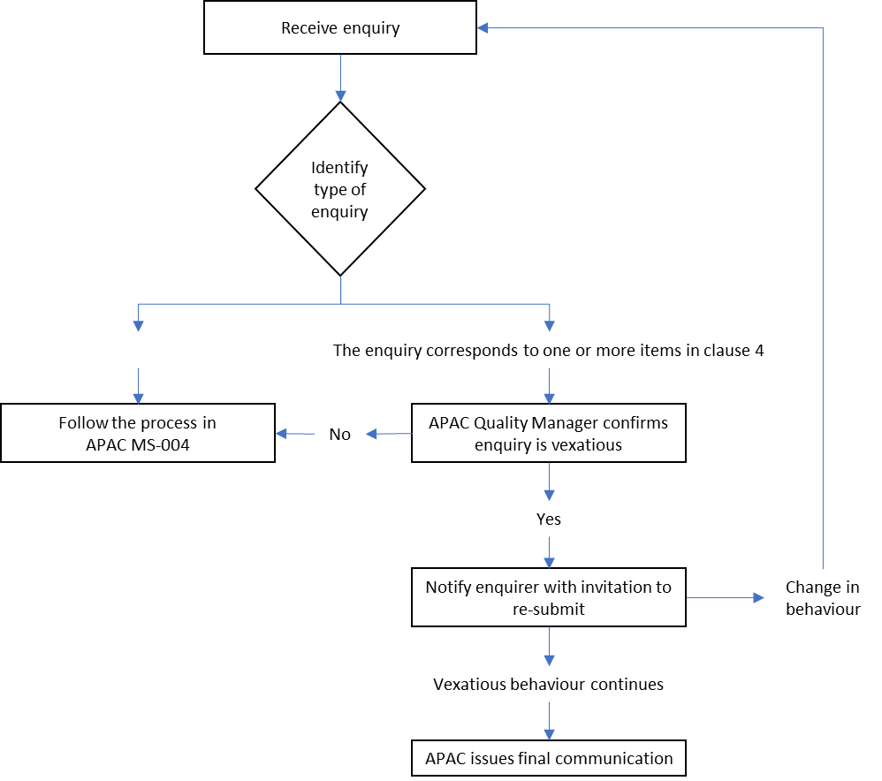

AMENDMENT TABLE
This table provides a summary of the changes to the document with this issue.
Section(s) | Amendment(s)

