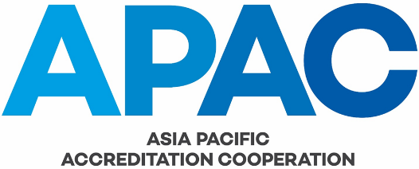

APAC Proficiency Testing Programs

Issue No. Draft 4
Issue Date 15 April 2021
Application Date

AUTHORSHIP
This document was produced by the APAC TC1 Proficiency Testing Sub-Committee (PTSC).

COPYRIGHT
Copyright in this document belongs to APAC. No part may be reproduced for commercial exploitation without the prior written consent of APAC.

FURTHER INFORMATION
For further information about APAC or this document please contact the APAC Secretariat at secretariat@apac-accreditation.org.

CONTENTS
1 PURPOSE 4
2 REFERENCES 4
3 BACKGROUND 4
4 POLICY and PROCEDURE 4
5 AMENDMENT TABLE 5

PURPOSE

The purpose of this document is to provide the policy for APAC’s involvement in the provision of proficiency testing programs and the procedure for approval by the APAC Executive Committee.

REFERENCES

The definitions that apply to this document are those established in the APAC Constitution and any further definitions as follows:

- ISO/IEC 17000, Conformity assessment – General principles and vocabulary

- ISO/IEC 17043, Conformity assessment – General requirements for proficiency testing

BACKGROUND

3.1 APAC (previously as APLAC) has traditionally run proficiency testing (PT) programs for laboratories accredited by APAC Members and non-accredited laboratories. The need for APAC to run its own PT programs has diminished over time due primarily to the increasing number of commercial programs now available globally.

NOTE See the links to PT provider databases on the APAC Proficiency Testing Programs webpage.

3.2 However, in some instances there continues to be a specific need for APAC to support the provision of PT programs through direct funding and administration by the APAC TC1 Proficiency Testing Subcommittee (PTSC), in accordance with APAC FGOV-013 Terms of Reference – PTSC.

POLICY and PROCEDURE

4.1 The PTSC is responsible for identifying specific needs for APAC to support and provide APAC PT programs. Once a need is identified, the PTSC shall propose an APAC Proficiency Testing Program using APAC FTEC2-001 APAC Proficiency Testing Program Proposal Form and submit it to the APAC TC1 Chair for presentation to the APAC Executive Committee.

4.2 The PTSC proposal shall include a justification as to how the proposed APAC PT program conforms with the following policy considerations regarding APAC involvement in PT programs:

- there are no suitable commercial programs, readily available (i.e. accessible, timely, relevant to participant’s technical activities, similar materials/matrices)”;

- there is a specific trade-related or other regional issue with testing;

- there is a need for a specific investigation of testing performance in one or more laboratories for which the use of commercially available programs is not feasible;

- there are sufficient potential participants; and

- there is a suitable PT provider.

4.3 A separate form shall be completed for each proposed proficiency testing program.

4.4 The Executive Committee shall consider the proposal and make a decision whether to approve the proposed APAC Proficiency Testing Program. If approved, the PTSC Chair is authorized to commence the proposed APAC PT program within the approved budget.

4.5 A PT program proposal and Executive Committee approval are not required if the PT program is already an agreed APAC/APMP Proficiency Testing Program and APAC has already approved a budget for its contribution to the program.

AMENDMENT TABLE

This table provides a summary of the changes made to this document:

Date | Section(s) | Amendment(s)
2021-06-10 | All | APAC Executive Committee approval.
2021-03-22 | All | Initial draft.

