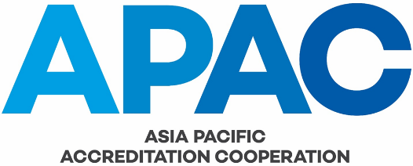

ADVICE OF CHANGES BY APAC MEMBER

APAC Full Members are required by APAC MRA-001 to ensure that other MRA signatories are advised of any significant changes in status and/or operating practices. Associate Members are requested to provide the same advice to other APAC members.

This checklist and form are to be used by APAC members when providing such advice via the APAC Secretariat.

Organisation name:

Please “tick” () the applicable boxes and provide the information requested. English versions of all relevant supporting information should be attached.

Change in organisation’s name (including of parent organisation)
Previous name:
New name:
Reason for change (e.g. merger of two organisations)

Change in legal status (including of parent organisation)
Previous legal status:
New legal status:
(Note: attach a copy of relevant documentation, e.g. government regulation, company registration document, etc)
Effect (if any) on any government recognition as an AB:

Changes in key personnel
Name(s) and position (e.g. CEO) of new personnel:
Name(s) and position of personnel who have left:
(Please attach a CV for new personnel)

Changes in organisational structure
Describe the changes:
Attach a copy of new organisation chart (“family tree”)

Significant change in the operation of the AB’s system
Describe the change:

Change in mechanism used to assess CABs
Describe the change:

Use of sub-contracted organisations to do assessments, either routinely
or from time to time
Name(s) of organisations used:
Relationship of organisations to APAC Full member:

Attach self-evaluation of how, and to what extent, the changes
described above impact on the AB’s technical competence and APAC MRA signatory status. This may include self-evaluation against the relevant clauses of ISO/IEC 17011.

Name:
Position:
Signature:
Date:

