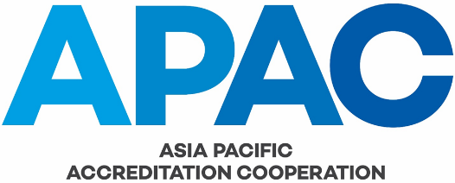

This form is to be used to record corrective actions that address nonconformities and comments that arise outside of the internal audit process (e.g. finding from an IAF/ILAC evaluation, APAC follow-up action from a complaint, etc).

Type | Requirement reference | Finding | Date / Person / Corrective action / Comment | Closure confirmation / Date / Person

Type: Nonconformity = NC#, Comment = C#;

