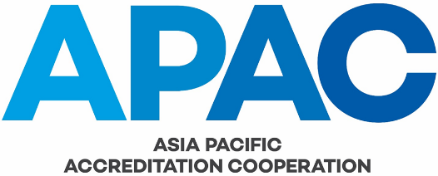

APAC APPEAL FORM

This APAC Appeal Form can be used by:
- APAC Members and Affiliates to appeal an APAC or Executive Committee decision in accordance with clause 14 of APAC GOV-001 APAC Constitution and APAC MS-004 APAC Complaints and Appeals Process; or
- APAC MRA signatories and APAC MRA applicants to appeal an APAC MRA Council decision in accordance with clause 9 of APAC MRA-003 APAC MRA Council – Rules for its Operation.

Appellants are to read APAC MS-004 Complaints and Appeals Process or APAC MRA-003 APAC MRA Council – Rules for its Operation as relevant prior to completing and submitting this APAC Appeal Form to the APAC Secretariat (secretariat@apac-accreditation.org).

Appeals must be referenced against a specific requirement in the APAC procedures and should include a reference to the specific finding(s) which the appellant wishes to raise an objection.

Appellant contact details
Prefix (e.g. Mr., Mrs. Ms., Dr.):
Given name:
Family name / Surname:
Organization:
Position:
Email address:
Contact number:

Appeal details
Specific APAC, Executive Committee or APAC MRA Council decision that is being appealed:
Specific clause in APAC procedures and/or specific finding that relates to this appeal | Description of appeal  (please provide a description of each matter included in the appeal on each single row) | Submitted evidence  (please list the evidence submitted as part of this appeal) | Desired action by the appellant

☐  (please tick/cross this box to indicate that you are authorised to make this appeal and that you agree with the declaration in order for this appeal to be processed) | Declaration  I, the undersigned accept this declaration and make this appeal having read APAC MS-004 Complaints and Appeals Process or APAC MRA-003 APAC MRA Council – Rules for its Operation as relevant. I confirm my agreement that this completed form, supporting evidence and any further correspondence in relation to this matter may be communicated by APAC to any person or organization (e.g. APAC Officers, personnel and advisors; APAC Members and Affiliates; APAC evaluators; the International Accreditation Forum (IAF) and the International Laboratory Accreditation Cooperation (ILAC); other regional accreditation cooperations; other accreditation bodies; and regulators). This appeal may be used by APAC for quality assurance and training purposes. APAC correspondence, including all communications with the appellant, and the final outcome of any appeal process remains confidential between the parties, unless APAC provides expressed written permission to release some or all of the information. All appeal decisions are considered final and binding, and APAC is not liable for any costs, expenses, damages or losses that may arise from this appeal.
 | Appellant signature: |  | Appellant  name: |  | Date:

