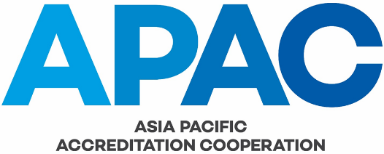

MRA Application Checklist

Note: On receipt of an application from an AB for APAC MRA signatory status, this form is to be completed by the APAC Secretariat and then submitted together with the application to the APAC MRA MC Chair.

Name of Accreditation Body Applicant:

Date of Application:

Date of final submissions of supporting documents:
GENERAL:
Completeness of information in the Application?
Is a Pre-Evaluation visit requested?
Preferred date of Evaluation:
Statement on the regional group(s) to which the applicant belongs, if any:
DOCUMENTS:
Have the following documents been supplied?
Set A Documents (in English)
General:
- Self-evaluation report against ISO/IEC 17011 and other APAC requirements by completing the template given in IAF/ILAC-A3;
- The applicant body’s quality documentation in which its policies and procedures, and the responsibility for implementation of the quality system are clearly described;
- Accreditation criteria and associated generally applicable technical criteria that the applicant body publishes;
- All other general criteria published which include formal rules or regulations affecting the applicant body’s operation and the responsibilities and obligations of its accredited organisations;
- A checklist or other cross-reference showing the applicant body’s compliance with the requirements of the relevant ISO(/IEC) standard(s);
- Details of any organisations to which assessment activities are sub-contracted, either routinely or from time-to-time (if not included in 1. above);
- Detailed scopes of accreditation (or draft scopes of accreditation) of all CABs to be visited during the evaluation visit.
Specific
- The written guidance, if any, provided for the calculation of measurement uncertainty for calibration laboratories, testing laboratories and RMPs;
- If applicable, the policy statement on the use of peer inspectors for inspection body assessments (if not included in 1. above);
- Operational procedures covering proficiency testing, including criteria for statistical evaluation and corrective action procedures;
- Summary listing of all proficiency testing activity undertaken in the last two years by accredited (and applicant) organisations;
- The policy for measurement traceability routes (if not included in 1. above);
- List of international comparisons in which the economy’s national metrology institute (NMI) has been involved
Set B Documents
- Any other documentation that describes the mechanics of operation of the accreditation system, including annual reports, questionnaires, newsletters, guidance documents, summary reports of proficiency testing programs (where applicable), etc;
- A copy of the applicant body’s directory or other listings providing the name and scope of accreditation of each accredited organisation. If the directory is published through the Internet, the web site address of the directory should be given;
- Descriptions of any separate functions or affiliations of the applicant body to activities other than accreditation (such as standards writing, etc);
- Description of the economy’s metrological infrastructure (e.g. national measurement institute or links to any other national measurement institutes);
- Details of any formal agreement or recognition to which the applicant body is party either nationally or internationally, including with government authorities, private sector organisations, other accreditation systems, etc, and;
- Reports of any recent evaluations carried out by other relevant organisations, if applicable.
Others, if any?
RECOMMENDATION:
Acceptance of application: NOTE: this is a request for a main scope extension and the above documents are to be provided to the appointed evaluator prior to any evaluation being undertaken.
If "No", the reason for rejecting the application:

Name of Person preparing this Checklist:

Date of Checklist:

